Scripts for Scene: **WT_Rotor**

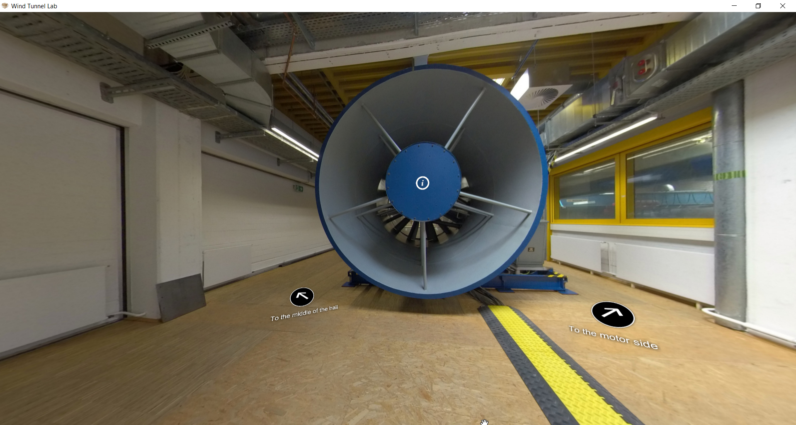

|  |  |  |
| --- | --- | --- |
| Nr | Hotspot (see red arrow) | Script |
| 1 | Hotspot: Short information about rotor | Revised text:  The Rotor (Fan) sucks the air inside the wind tunnel and create a wind flow flowing from inlet into the wind tunnel. The fan is rotated by an AC motor on the right side. The diameter of rotor is 2.23 m. |